A CRM APPLICATION FOR THECHAISHOP&CO

User Story:
As a sales representative at TheChaiShop&Co, I want to efficiently manage customer relationships and streamline sales processes using our CRM application.
I want to easily access and update employer details, as well as distinguish between online and offline customer records using record types, allowing for personalized interactions.
Additionally, I need the application to automate sales calculations, such as order quantity and total bill amount, to ensure accurate and efficient transactions.
Moreover, I require the ability to generate insightful reports and dashboards to summarize and analyze sales data effectively, aiding in decision-making and strategy development.
Lastly, I would like the application to automate email notifications to customers on their birthdays, informing them of special offers tailored to celebrate their special day, enhancing customer engagement and loyalty.

1. INTRODUCTION

1.1 Project Overview :

The project “A CRM Application for TheChaiShop&Co” focuses on developing a Salesforce-based Customer Relationship Management (CRM) system to manage customer, employer, and enterprise accounts efficiently. The system automates sales processes, maintains customer records, generates reports, and improves customer engagement through automated notifications.

The project user story and objectives are defined in the initial section of the document

1.2 Purpose :
The purpose of this project is to:

Streamline customer relationship management

Automate billing and order calculations

Improve data accuracy

Enable data-driven decision-making

Enhance customer engagement through email automation

2. IDEATION PHASE
2.1 Problem Statement (Customer Problem Statement Template)

PS | I am (Customer) | I’m trying to | But | Because | Which makes me feel
PS-1 | Sales Representative | Manage customer orders and billing | Calculations are often incorrect | Order quantity and billing are manual | Stressed and inefficient
PS-2 | Store Manager | Monitor sales and customer records | Reports are delayed and incomplete | Data is stored in multiple files | Confused and dissatisfied
PS-3 | Customer | Receive personalized offers and updates | I do not get timely notifications | There is no automated communication | Disconnected and undervalued

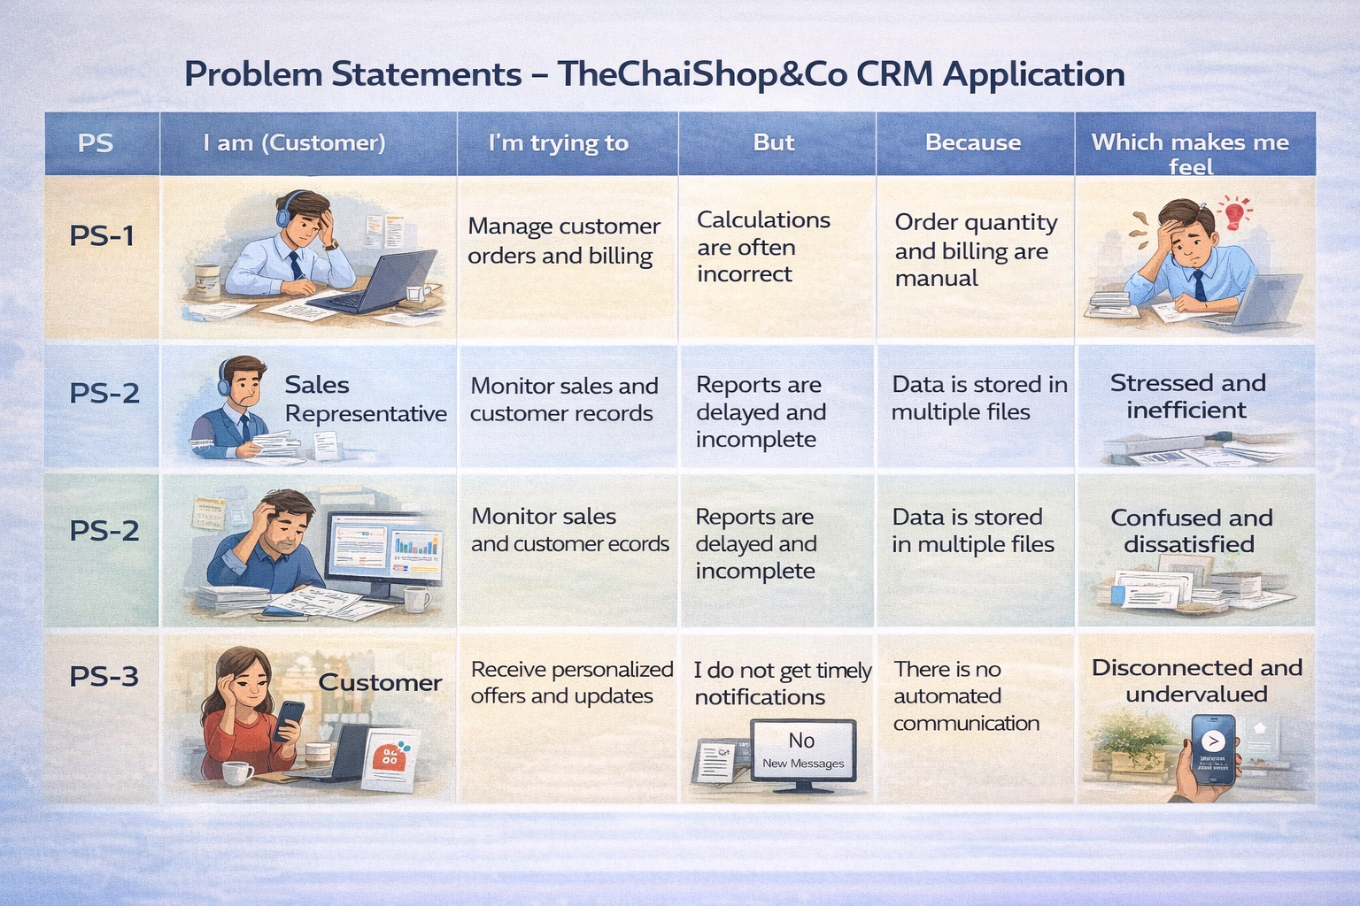

2.2 Empathy Map Canvas
Target Users

Sales Representatives

Managers

System Administrators

Business Analysts

Empathy Analysis

Aspect | Description
Think & Feel | Need accurate customer data and reports
Hear | Feedback from management
See | Multiple registers and spreadsheets
Say & Do | Enter data manually
Pain | Errors, delays, data loss
Gain | Automation, fast reports

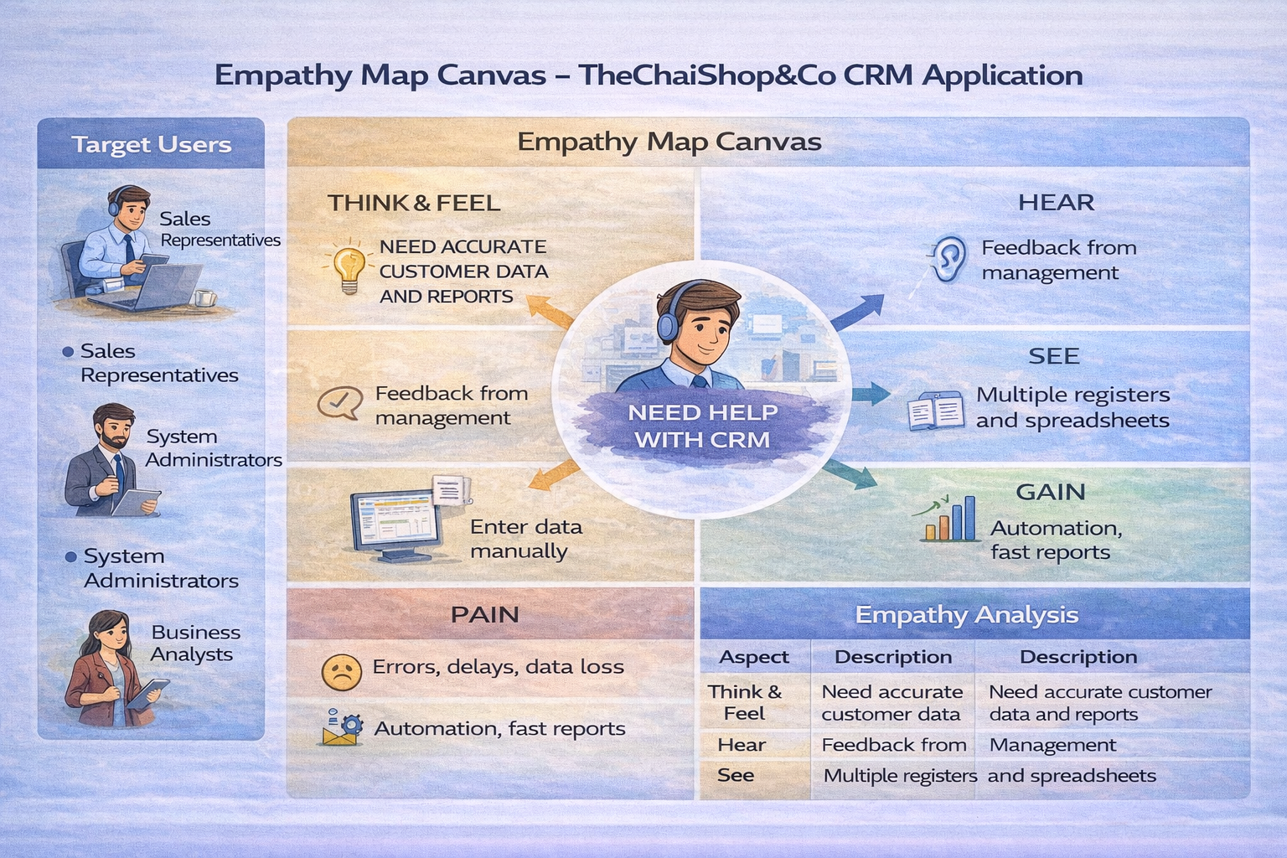

2.3 Brainstorming
Brainstormed Ideas

Manual CRM system

Excel-based management

Web-based CRM

Salesforce-based CRM

Automated email system

Selected Idea:
Salesforce-based CRM Application for TheChaiShop&Co..

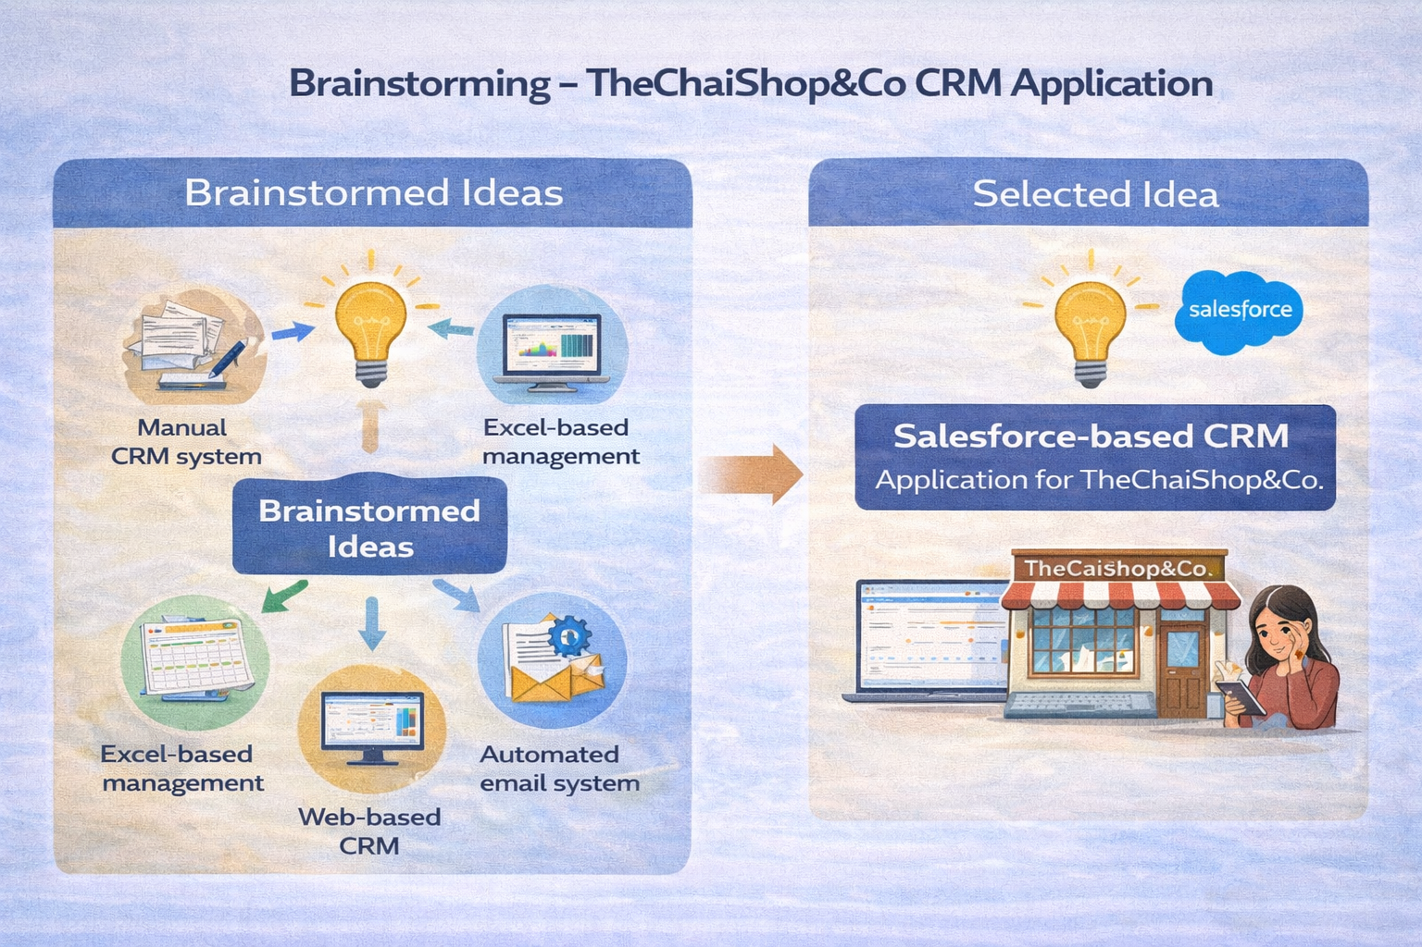

3.REQUIREMENT ANALYSIS PHASE

3.1 Customer Journey Map
Journey Stages:

Login

Access CRM Application

Enter Customer Data

Generate Orders

Calculate Bills

View Reports

Decision Making

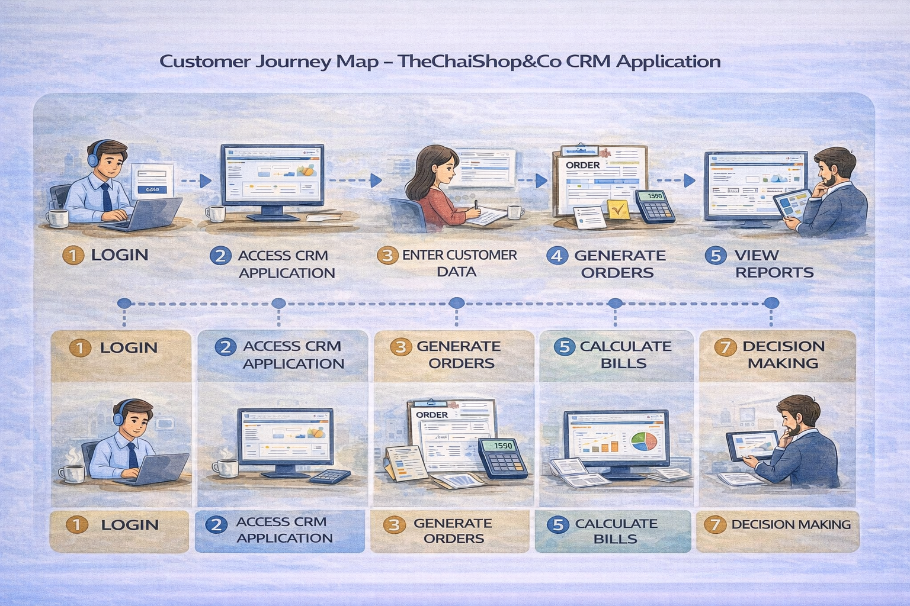

3.2 Solution Requirements
Functional Requirements

FR No | Requirement
FR-1 | User Login
FR-2 | Object Creation
FR-3 | Data Entry
FR-4 | Billing Automation
FR-5 | Report Generation
FR-6 | Email Automation

Non-Functional Requirements
NFR-1: Usability
The system should be easy to use for sales representatives, managers, administrators, and analysts without requiring technical training.
Requirements :

Simple and intuitive user interface

Clear navigation menus

Easy-to-understand forms

User-friendly dashboards

Example:
A new sales employee should be able to log in, enter customer details, and generate orders within a few minutes without help.
Salesforce Lightning UI provides drag-and-drop features and easy navigation.
NFR-2: Security
The system must protect customer and business data from unauthorized access.
Requirements:

Role-based access control

Secure login authentication

Encrypted data storage

Data backup and recovery

Examples:

Profiles and permission sets

Object-level and field-level security

Restricted billing access

Secure login and password policies

NFR-3: Reliability
The CRM system should work correctly at all times and store data accurately without loss.
Requirements:

Automatic data saving

Regular system backups

Error handling mechanisms

Stable cloud environment

Example :
If a user enters order data and the internet disconnects, the system should save the information and restore it later.
Salesforce cloud ensures automatic backups.

NFR-4: Performance
The system should respond quickly and handle large amounts of data efficiently.
Requirements:

Fast page loading

Quick report generation

Smooth dashboard rendering

Minimal delay

Example: When a manager generates monthly sales reports for hundreds of customers, the report should load within 2–3 seconds.
Optimized queries and caching improve speed.

NFR-5: Availability
The system should be accessible whenever required.
Requirements:

24/7 system availability

Minimal downtime

Cloud-based hosting

Disaster recovery

Example: Managers should be able to access the CRM system during peak business hours, weekends, or late nights.
Salesforce cloud provides high uptime.

NFR-6: Scalability
The system should support business growth without affecting performance.
Requirements:

Ability to handle more users

Support increasing customer data

Expandable storage

Maintain system speed

Example: If TheChaiShop&Co expands to multiple branches, the CRM system should support thousands of customers without slowing down.
Salesforce infrastructure automatically scales.

3.3 Data Flow Diagram
User → Salesforce UI → Custom Objects → Validation Rules → Flows → Reports → Dashboards.
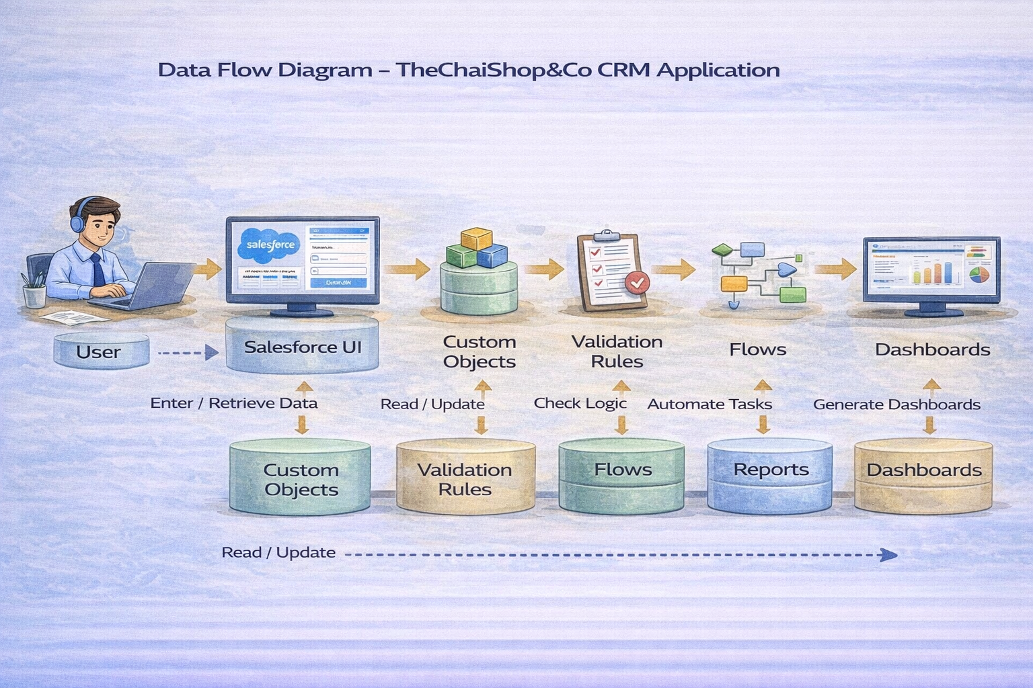

3.4 Technology Stack
Layer | Technology
Frontend | Salesforce Lightning
Database | Salesforce Cloud
Automation | Flows
Backend | Salesforce Platform
Analytics | Reports & Dashboards

4. PROJECT DESIGN PHASE

4.1 Problem–Solution Fit
The CRM system replaces manual records with automated data management. Cloud storage prevents data loss, dashboards improve analysis, and real-time reports eliminate delays. This ensures accurate and timely business insights generation.

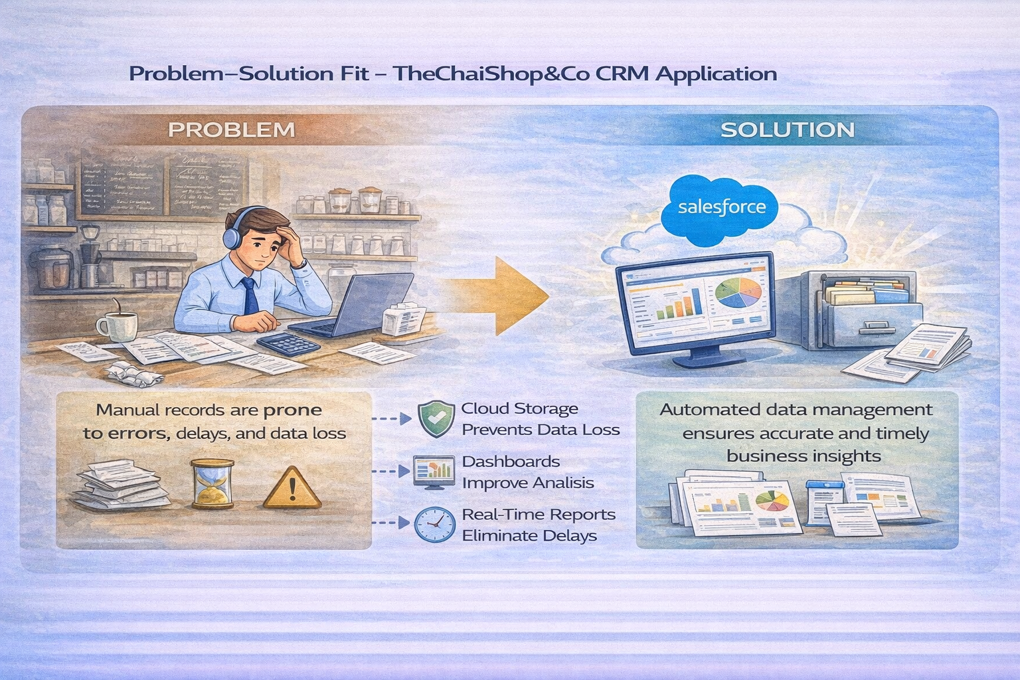

4.2 Proposed Solution
Functional Requirements

Parameter | Description
User Login & Authentication | Allows authorized users to securely log in to the CRM system using valid credentials.
Customer Record Management | Enables users to create, view, update, and delete customer details such as name, contact number, and address.
Employer & Enterprise Management | Allows management of employer and enterprise account information for business operations.
Order Management | Supports creation and tracking of customer orders, including order quantity and product details.
Automated Billing System | Automatically calculates total bill amount using formula fields based on order quantity and pricing.
Validation Rules | Ensures accurate data entry by validating fields such as phone number, PAN, and Aadhaar.
Record Types & Page Layouts | Provides different record types and layouts for various customer and enterprise categories.
Global Picklists | Maintains standardized values for fields such as product type, category, and status.
Email Notification System | Sends automated emails to customers for birthdays, offers, and order confirmations.
Workflow & Flow Automation | Automates tasks such as updating records and triggering alerts using Salesforce Flows.
Report Generation | Generates detailed reports on sales, customers, and enterprise performance.
Dashboard Visualization | Displays real-time analytics through interactive dashboards and charts.
Data Backup & Recovery | Ensures secure storage and recovery of business data in the Salesforce cloud.
User Role Management | Controls system access using profiles and permission sets for different users.

4.3 Solution Architecture
Architecture Layers

Presentation Layer – Lightning UI

Application Layer – Flows and Logic

Data Layer – Custom Objects

Analytics Layer – Reports and Dashboards

This layered architecture ensures modularity, scalability, and maintainability.
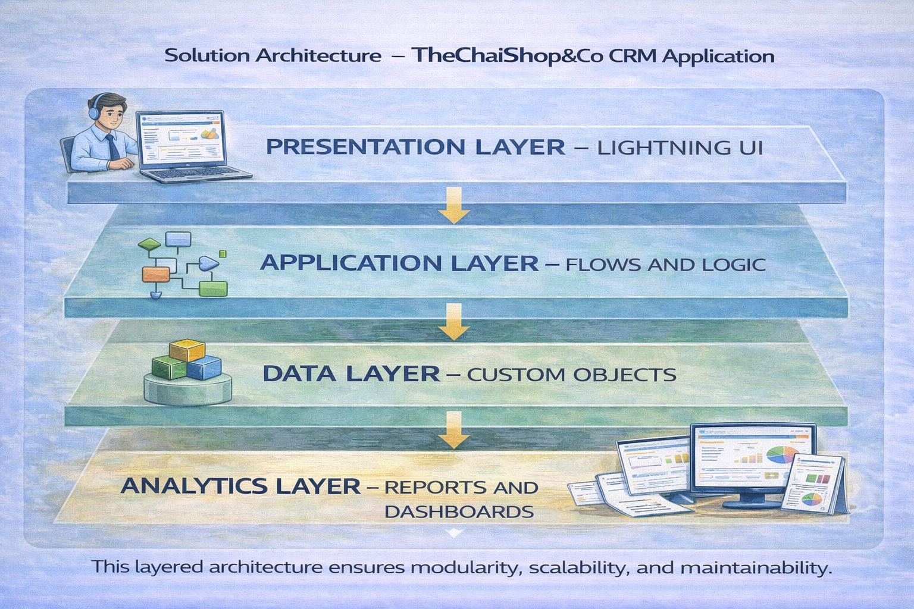

5. PROJECT PLANNING & SCHEDULING

5.1 Project Planning

The project followed an Agile-based development approach with defined milestones and sprints.

A Salesforce Developer account was created to set up the development environment.

Custom objects were designed to store customer, employer, and enterprise data.

Custom tabs and a Lightning Application were developed for easy system navigation.

Fields, relationships, and global picklists were configured to ensure data consistency.

Page layouts and record types were created based on user roles and customer categories.

Validation rules were implemented to prevent incorrect data entry.

Email templates and automated flows were developed for customer notifications.

Reports and dashboards were created for performance monitoring and analysis.

Regular sprint reviews and testing were conducted to track progress and resolve issues.

The project was completed within the planned timeline through systematic scheduling.

Product Backlog, Sprint Schedule, and Estimation (4 Marks)
Use the below template to create product backlog and sprint schedule
Sprint | Functional Requirement (Epic) | User Story Number | User Story / Task | Story Points | Priority | Team Members
Sprint-1 | Developer Setup | USN-1 | As an admin, I want to create a Salesforce developer account so that I can configure and deploy the TheChaiShop&Co CRM application. | 1 | High | Member1
Sprint-1 | Data Modeling | USN-2 | As an admin, I want to create Customer, Employer, and Enterprise objects so that business data can be stored and managed systematically. | 3 | High | Member2
Sprint-2 | Data Modeling | USN-3 | As a user, I want separate tabs for each object so that I can easily navigate and manage CRM records within the application. | 3 | High | Member3
Sprint-2 | Data Modeling | USN-4 | As a manager, I want a dedicated Lightning App so that all CRM operations are accessible from a single dashboard. | 3 | High | Member4
Sprint-2 | Data Modeling | USN-5 | As an admin, I want to create customer and order fields so that complete sales and billing details can be captured accurately. | 5 | Medium | Member1
Sprint-2 | Data Modeling | USN-6 | As a user, I want customized page layouts for different record types so that only relevant information is displayed during data entry | 5 | High | Member2
Sprint-2 | Data Modeling | USN-7 | As a manager, I want separate record types for Retail and Enterprise customers so that different business categories can be managed efficiently. | 5 | Medium | Member3
Sprint-3 | Automation | USN-8 | As a system, I want to validate customer details and order inputs so that incorrect data entries are prevented. | 3 | High | Member4
Sprint-3 | Automation | USN-9 | As a system, I want automated flows to send email notifications so that customers receive timely updates and offers. | 5 | High | Member1
Sprint-4 | Automation | USN-10 | As a system, I want to automatically calculate billing amounts so that invoices are generated without manual effort. | 5 | High | Member2
Sprint-5 | Reports | USN-11 | As a manager, I want sales and customer reports so that I can monitor business performance and make informed decisions. | 4 | High | Member3
Sprint-6 | Dashboards | USN-12 | As a manager, I want visual dashboards so that I can quickly analyze sales, customers, and enterprise performance. | 4 | Medium | Member4

Project Tracker, Velocity & Burndown Chart: (4 Marks)
Sprint | Total Story Points | Duration | Sprint Start Date | Sprint End Date (Planned) | Story Points Completed (as on Planned End Date) | Sprint Release Date (Actual)
Sprint-1 | 20 | 6 Days | 24 Oct 2022 | 29 Oct 2022 | 20 | 29 Oct 2022
Sprint-2 | 20 | 6 Days | 31 Oct 2022 | 05 Nov 2022
Sprint-3 | 20 | 6 Days | 07 Nov 2022 | 12 Nov 2022
Sprint-4 | 20 | 6 Days | 14 Nov 2022 | 19 Nov 2022

6. Project Development Phase:

Project Flow
Milestone 1 : Creation of developer account
Milestone 2 : Object Creation
Milestone 3 : Tabs
Milestone 4 : The Lightning App
Milestone 5 : Global Picklist
Milestone 6 : Fields and Relationships
Milestone 7 : Creation of Page Layout
Milestone 8 : Creation of Record Types
Milestone 9 : Validation rules
Milestone 10 : Email Templates
Milestone 11 : Flows
Milestone 12 : Reports and Dashboards
Milestone 13 : Conclusion

